Descent to the Underworld
Death is a something that even today we know scarily little about. We know that we all die eventually, and we have a better understand of the things that kill us today than we did in ancient times, yet even now there remains the mystery of what happens next. Across the approximately 300,000 years human beings as we are have existed, the countless cultures have all had their own interpretations of what happens to us when we die, with Ancient Greece being no exception. Although Ancient Greek history can be broken down into three different periods, Archaic, Classical, and Hellenistic, each period having a multitude of different city states, or poleis, with all of which having potential differing religions and belief of the afterlife, for the most part they all had similarities in their views of death, which can be reflected in many objects uncovered. For this treasure trail, you must locate objects relating to death, research and analyses them, and finally fill in what you learn in the sheet. Try to find each time in the order they appear on the sheet as it reflects the stages in which the Ancient Greeks believed a person would enter the Underworld.

Funerary Rituals
Anointing of the Body
To purify a body for funerary rituals, the Greeks would commonly bathe the deceased body in water, then anoint it in oil. The item below is an oil lamp which, although unlikely used during funerary practice, still produced oil.
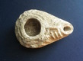
Locate Item and State:
- Fabric of Item:
- Style of Item:
- Period and Date of Item:
Questions About Oiling (Bonus Points)
- What Was Ancient Greek Oil Typically Made From? –
- Approximately When did the Greeks Begin Anointing Themselves with Oil? –
- Name One Other Reason Greeks Anointed Themselves with Oil –

Preparation for the Journey
Just before burial, an obol, type of Greek currency, would be placed upon the body of the deceased. The purpose of this was so that the soul of the deceased would be able to pay the ferryman Charon in order to be ferried across the rivers to the Underworld. Although this obol presented has the image of Athena on it, while most obols given to Charon had the ferryman himself on them, it is still currency that could have been used as payment for Charon, although it is unlikely.
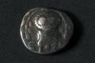
Locate Item and State:
- Period and Date of Item:
- Material of Item:
- Animal on Item:

Questions About Obols (Bonus Points)
- What Kind of Places on the Body Did They Put Coins On? –
- Can You Name Another Kind of Ancient Greek Currency? –
- What Metal Were Obols Typically Made From? –

Respect for the Dead
After burial the dead, if they could afford, were placed in tombs or beneath graves, similarly, to as is done today, although for obvious reasons, their graves and tombs would have looked much different then than they do today. Out of respect for the deceased, typically a woman/women would care for a tomb or grave, as is depicted on this pot image below.

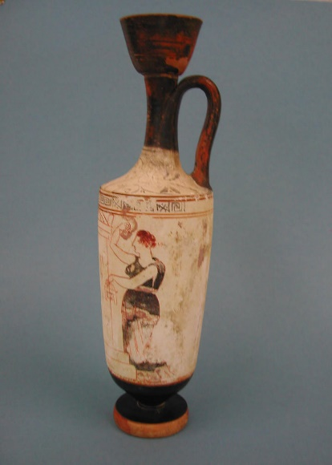
Locate Item and State:
- Material of Item:
- Period and Date of Item:
- Fabric of Item:
Questions About Graves (Bonus Points):
- What Was a Common Material Tombs Were Made From? –
- Which Greek City Was Popular for Cremation as Opposed to Burials? –
- When Did the Ancient Greeks Begin Burying People? –

The Journey to the Afterlife
Escorted by Hermes
The God of Travelers, Thieves, and Athletes, Hermes was tasked with the duty of escorting the souls of the dead to the River Styx to begin their journey to the Underworld. The Ancient Greeks believed that when a person’s life was about to end, Thanatos, God of Death, would cut a strand of their hair, causing them to die. When their souls left their bodies, Hermes would escort them to Charon, the Ferryman of the Underworld.
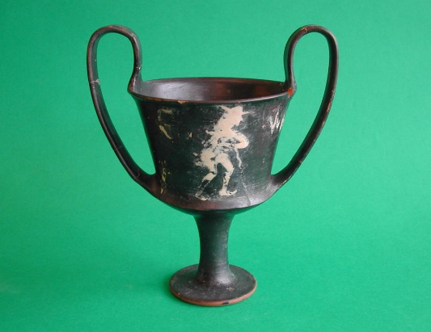
Locate Item and State:
- Type of Item:
- Location Item Was Discovered:
- Period and Date of Item:
Question About Hermes (Bonus Points):
- What Was Hermes’ Main Role as a God? –
- What Instrument Did He Commonly Play? –
- Who Was Hermes’ Father? –

Time to Pay the Ferryman
At the bank of the River Styx, the Ferryman Charon would greet the dead, and request them to pay him. If they had the money that he required to ferry them across then they would be left on the bank without access to the land of the dead. Trapped on the other side of the river, the dead would have no alternative but to wonder aimlessly across the land of the living and haunt their friends and relatives for not providing them with what they required to get across.
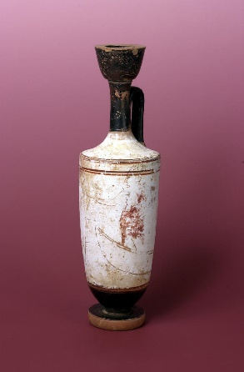
Locate Item and State:
- Shape of Item:
- Material of Item:
- Fabric of Item:
Questions About the Ferryman, Charon (Bonus Points):
- Who Bested Charon in Combat to Be Ferried Across? –
- What Other River Did Charon Ferry the Dead Across? –
- What Famous Song by Chris De Burgh Tells of Charon? –

The Queen of the Dead
Once the deceased were ferried across, they finally had entered the Underworld. The Underworld itself consisted of three different levels: Elysium (where good people went), Tartarus (where bad people went), and the Asphodel Meadows (where the undecided went). This dominion was governed over by Hades, God of the Underworld, and his wife Persephone, Goddess of Spring Growth and Queen of the Underworld. Persephone’s role was similar to her husband’s, to rule over the land of the dead while ensuring that they do not escape and go back to the land of the living.
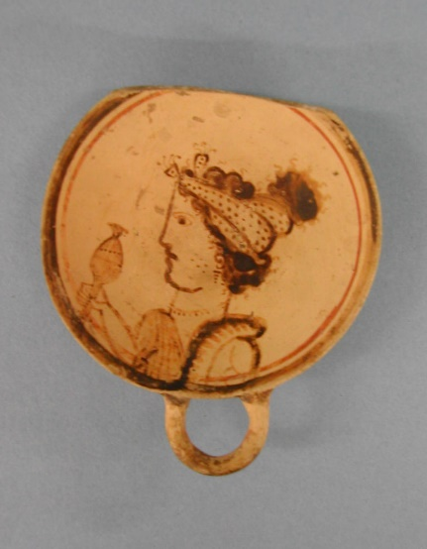
Locate Item and State:
- Material of Item:
- Period of Item:
- Artist of Item:
Questions About Cerberus (Bonus Points):
- Who was Persephone’s Mother? –
- How Much of the Year Would Persephone be in the Underworld For? –
- How Many Children Did Persephone and Hades Have Together? –

